How To Select Peptides in Recombinant Kinase Profiles (SOP)

CDRL
1/20/2022

Goal:
- Map peptide to kinases based on recombinant kinase signatures.

Notes:
- This is specifically designed for recombinant kinase signatures with variable concentrations.
- Selecting peptides for recombinant kinase signatures is not as straight forward as analyzing disease models. Because instead of just doing a two-group comparison, we’re comparing multiple profiles together.
- Normally, like with any selection process, you can choose to be stringent or more lenient. In this case, we want to be more strict on how we select peptides. I’ll show you in which steps you could adjust the stringency scale.
- The example shown in this document is based on kinase profiles with three concentrations (2.5ng, 25ng, 250ng). You will encounter different concentrations in different profiles, so you have to adjust and explore the data accordingly.

Steps:
- Exclude highly saturated peptides with krsa_qc_steps(data, sat_qc = T). Lenient: sat_qc = F
- Don’t filter any peptides for low signal or non-linearity for the global signal modeling. krsa_filter_lowPeps(data_pw_200, 0), krsa_filter_nonLinear(data_modeled$scaled, 0). Reason: some of the recombinant kinases have very low signals in general (especially the ones with the low concentrations).
- Always use none scaled heatmaps to show true/actual activity. krsa_heatmap(scale = "none”)
- It’s important to generate the heatmaps and thoroughly investigate the row/peptide clusters to determine which peptides show non-specific binding/activity. Exclude peptides that show signals in the negative controls (no ATP, or heat inactivated), or peptides that show similar patterns regardless of the kinases (see example below).
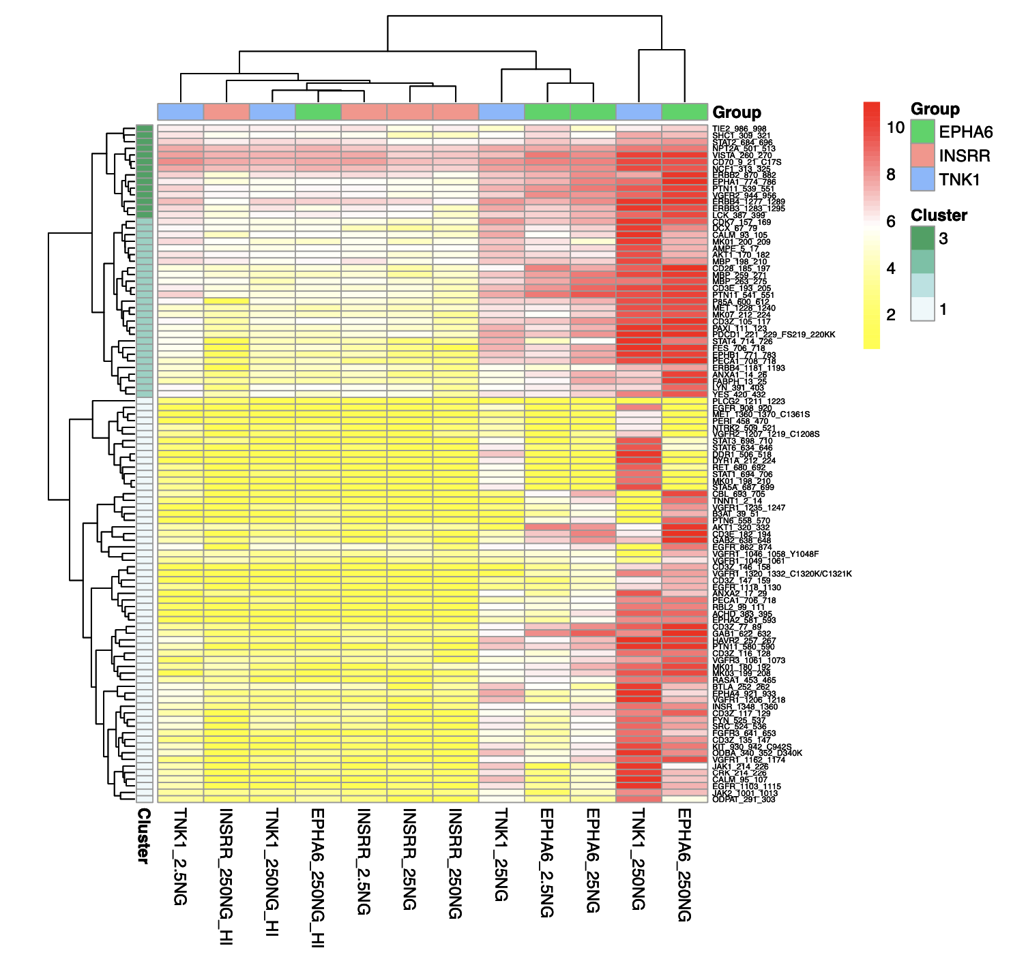

- Notice how cluster 3 shows some activity even in the negative control samples. So we will exclude that cluster of peptides. Cluster 2 shows similar patterns across kinases, suggesting non-specific binding/activity. So to be strict, I excluded both cluster 2 and 3.
- Moving cluster 1 forward, now we want to examine an increase of activity as we increase the concentration. We can’t just compare highest concentration vs negative control. Some peptides will show linearity, some won’t. We will exclude the non-linear peptides (see example)
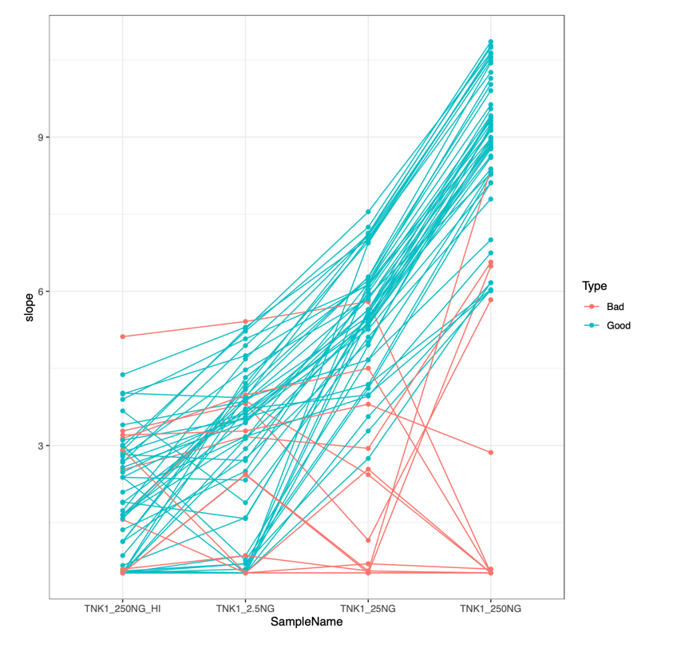

- After removing these non-linear/”bad” peptides, now we get the final list for that kinase.
